**LOVELY PROFESSIONAL UNIVERSITY**

**Academic Task-II**

**Mittal School of Business Name of the faculty member: Dr. MRIDULA MISHRA**

**Course Code:** HRMM504 **Course Title: Organization Behavior and Human Resource Dynamics-II Task Title:** Analyze the role of HRIS

**Student’s Roll no:** RQ2240A19 **Name:** Nowneesh T  **Student’s Reg. no:**12202342

**Class: MBA Module:** 2nd  **Section: Q2240**

**Max. Marks: 30 Date of Allotment: 14-11-2022 Date of Submission: 13-12-2022**

**Declaration:**

I declare that this Assignment is my individual work. I have not copied it from any other student’s work or from any other source except where due acknowledgement is made explicitly in the text, nor has any part been written for me by any other person.

**Student’s Signature:** *Nowneesh T*

**Evaluator’s comments (For Instructor’s use only)**

|  |  |  |
| --- | --- | --- |
| **General Observations** | **Suggestions for Improvement** | **Best part of assignment** |
|  |  |  |

Evaluator’s Signature and Date:

Marks Obtained: _______________ Max. Marks: ______________

**Advantages of HRIS Model**

1. A decrease in the price of data storage for human resources.

2. More rapid data retrieval and processing.

3. Lessening the duplication of work, which lowers costs.

4. Accessibility to current and accurate information about human resources.

5. More thorough analysis results in better decision-making.

6. More thorough career guidance and planning at all levels.

7. Better report quality.

8. More responsiveness to environmental changes.

9. Increased system transparency

**Main Uses of HRIS**

**Personnel Administration:**

It includes a worker's private information. Name, residence, date of birth, marital status, and the date of joining the organisation are a few examples. It also includes the employee's next of kin's name and address. The employee is described by these details.

**Salary Administration:**

The provision of a report comprising data such as current salary, benefits, most recent pay rise, and anticipated pay increase in the future is one of the purposes of HRIS.

**Leave/Absence Increase:**

The HRIS is also used to monitor employee absences and leave. This is accomplished by keeping track of each employee's leave history. Every employee is eligible to receive an identification card with their unique token number encoded on it. The identity card should contain a record of the employee's entrance and departure from the organisation. This lessens the possibility of error or oversight when determining the compensation for each employee.

**Skill Inventory:**

Another use for the HRIS is tracking skill databases and employee skill recording. Such a talent database aids in identifying individuals who possess the qualifications for particular roles or tasks inside an organisation.

**Medical History:**

Data on occupational health is also kept up to date in the HRIS for things like accident monitoring and industrial safety requirements.

**Performance Appraisal:**

HRIS keeps track of information from performance reviews, including the due date, possibilities for promotion, ratings for each performance criterion, and similar information, in order to provide a complete picture of an employee. The factual data from the HRIS may be merged with the textual information, and the resulting information can be utilised for training purposes as well as to influence employee mobility through transfers and promotions.

**Manpower Planning:**

HRIS keeps track of information from performance reviews, including the due date, possibilities for promotion, ratings for each performance criterion, and similar information, in order to provide a complete picture of an employee. The factual data from the HRIS may be merged with the textual information, and the resulting information can be utilised for training purposes as well as to influence employee mobility through transfers and promotions.

**Recruitment:**

The most crucial aspect of HRM is recruitment. By keeping track of the specifics of the steps used during employee recruiting, HRIS significantly aids in the hiring process. These might include the price, the hiring process, and the amount of time needed to fill positions at various levels.

**Career Planning:**

HRIS enables positional growth of workers by giving required information, such as which employees have been targeted for specific roles. With other words, HRIS aids in succession planning.

**Analysis for HRIS development**

Each participating function is taken into account for data gathering in order to conduct a requirements analysis. What forms of data, for instance, will be required if the combined function of staffing and recruitment is included? The database may need to handle more users since the firm may decide to grow. What details will be recorded and how, if compensation data is included? All necessary areas are validated, together with projected database space and software integration requirements, prior to the start of the design phase.

**Design of HRIS**

The four steps involved in designing of HRIS are as follows: 1. Determination of Information Needs 2. Designing the System 3. Implementation 4. Monitoring and Evaluation.

#### 1. Determination of Information Needs:

#### The fundamental inputs for decision-making are data and information. Managers at various levels could require various kinds of information. Therefore, the first stage in creating HRIS is to determine the information the managers require. This entails a thorough investigation of the operations carried out within the organisation.

#### Analysis of work patterns, their connections, and the HRIS's limitations is also necessary. It is true that these elements can vary from organisation to organisation, industry to industry, and even occasionally within the same organisation and industry.

#### 2. Designing the System:

#### At this point, the information flow is organised to be economical and to meet the information requirements of managers. It is crucial to note that HRIS does not need a distinct design because it is a component of the Management Information System (MIS). However, creating recommended processing methods for the intended data set by managers at various levels may be necessary when designing an HRIS.

#### 3. Implementation:

#### The HRIS is truly configured at this point. Employees receive the skills they need through orientation and training programmes in order to manage the system efficiently. With the aim of integrating the HRIS with different existing organisational components, facilities are also expanded and modernised, and processes are suitably simplified.

#### 4. Monitoring and Evaluation:

It entails evaluating the effectiveness, or perhaps the system's contribution to the organization's overall human resource management. As a result, weaknesses are found, and remedial actions are made to guarantee its efficient operation. The system is regularly assessed in order to take into account changes that occasionally occur both inside and outside the organisation.

**HRIS Implementation, testing and deployment**

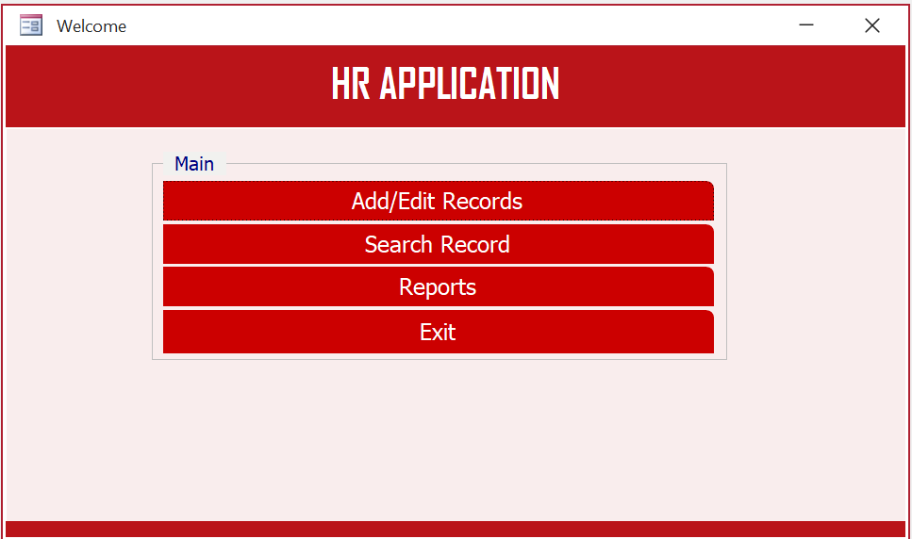

The above screen is mainly used for HR managers to update the employees data for the company.

**Add Records**

It is used to add records of the employee and update their data on the daily basis.

**Search Record**

It is used to search for the records of the employeers.

This is the add record page. We can add and update data of employees.

The above tabs are available to move to other features.

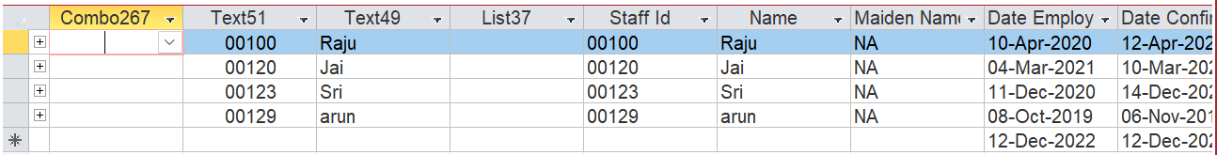

**Database View:**

The above image is showing the database for the application where data are stored.

This was the parameter section. In this section, we have to provide month and year. Then you can get the data of the salary which was provided in that month and year.

**Eg:** Month = May, Year = 2022

Then application will give the data of the salaries which was shown in the below image.



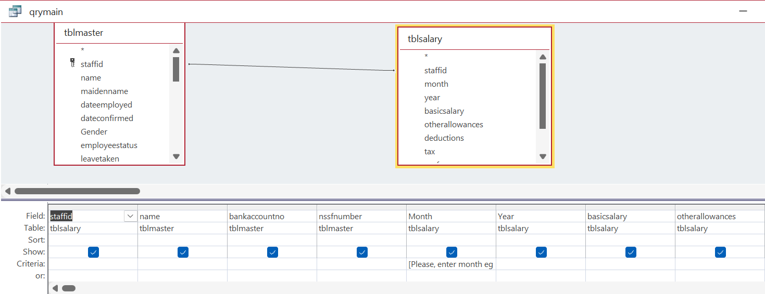

The Above image show the schema or design view of the database. In the above table, staffId was the primary key. Salary was linked with the staffId.

You can explore more features in the below file icon, which was developed by myself.

The below file will definitely work fine.



1. The above icon contains all my work on HRIS.
2. By clicking the icon, the Microsoft access will be opened.
3. Wait for few seconds, It will work as you expected.

Alternate use this link: <https://drive.google.com/file/d/13Le0L_B88TFcSe64IPGe_6xxxx9_QGYG/view?usp=share_link>

**Conclusion**

HRIS will help HR people a lot. It will make HR people work more easier. The mistakes will be done in rare case. With the use of MS access, It was cost efficient. MS access worked absolutely fine. But if we want more feature, then we have to go with the cost software for better user experience. Becaues the MS access will provide basic work of the HRIS. It might not be good for high human resource organizations.